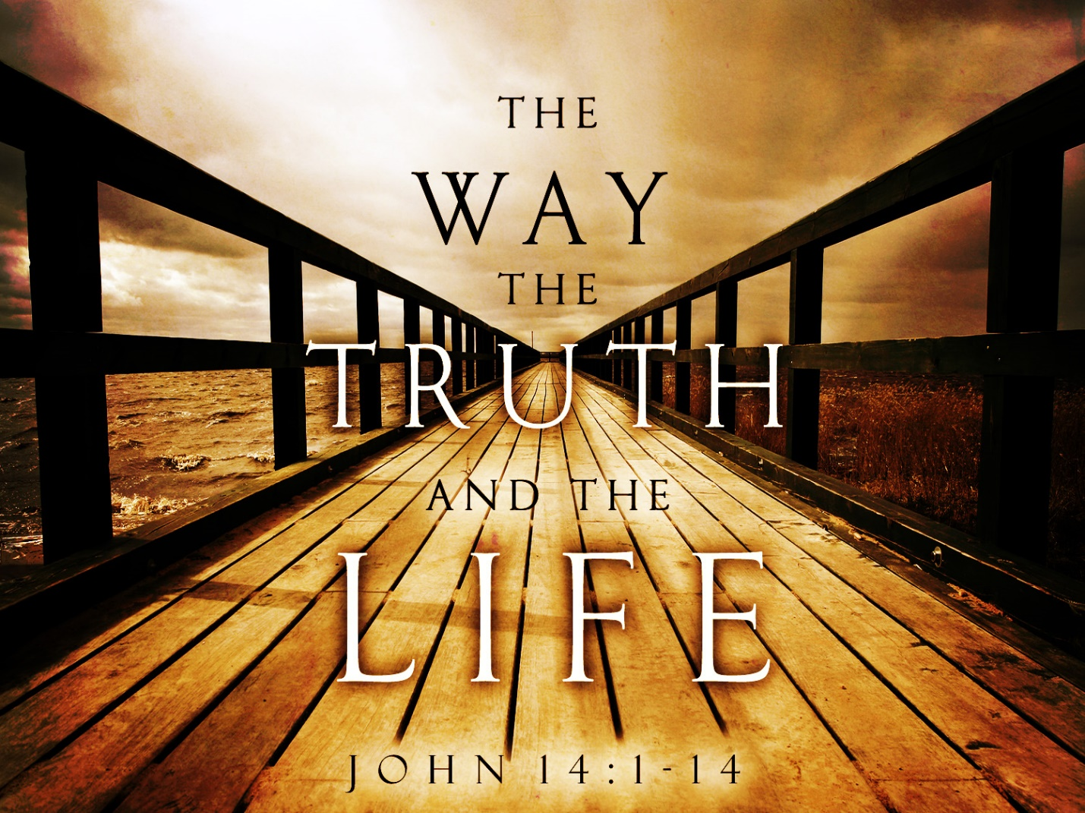

Last week we talked about the first part of John 14:6 - Yahushua is “The Way”

### “The Way” NT:3598 – hodos - Properly, a travelled way, road: see Matt 2:12. A traveler’s way, journey, travelling: Matt 5:25 - Metaphorically, denotes a course of conduct, a way (i.e., manner).

### Matt 7:12-14 - The Golden Rule “12 "So whatever you wish that others would do to you, do also to them, for this is the Law and the Prophets. 13 "Enter by the narrow gate. For the gate is wide and the way is easy that leads to destruction, and those who enter by it are many. 14 For the gate is narrow and the way is hard that leads to life, and those who find it are few.

Here are three of the questions I asked everyone to go into prayer and ask God to see on what road you are traveling:

* Are you in bondage to the ways of the world? Maybe the snare of addiction?
* Is Yahuah and His kingdom your priority or does something else take a priority?
* Is your life a testimony of the love of Yahushua? Loving without expectations.
  + What would your brother or sister or wife or husband say?

Are we totally surrendered to his will and way or not? Do you trust God with everything? You can’t be on the fence and partly rely on your own experiences, plans, emotions, etc. You need to walk in the spirit 100%

**We must die to sin and walk in the newness of life (be followers of the way Jesus walked).**

**From Got Questions: “**Paul speaks of a crucifixion that happens to the believer through his or her union with Jesus Christ: “I have been [crucified with Christ](https://www.gotquestions.org/crucified-with-Christ.html) and I no longer live, but Christ lives in me” ([Galatians 2:20](https://www.bibleref.com/Galatians/2/Galatians-2-20.html); see also [Romans 6:6](https://www.bibleref.com/Romans/6/Romans-6-6.html)). But in [Galatians 5:24](https://www.bibleref.com/Galatians/5/Galatians-5-24.html), it is the believer who has taken action. Crucify the flesh describes a deliberate putting to death of the old flesh nature.  
  
Paul’s instruction was inspired by Jesus Christ Himself, who said, “If anyone wants to follow after me, let him deny himself, take up his cross, and follow me.” (Mark 8:34).  
  
Take up the cross is a figure of speech closely related to crucify the flesh. Believers are to behave like a person carrying his own cross to the place of his execution. Paul follows the Lord’s words to their logical conclusion. Not only must believers pick up and carry their cross, but they must also make sure their death sentence gets carried out. Crucifying the flesh illustrates the putting to death of selfish, sinful desires.  
  
Believers are to take their old flesh nature and, figuratively speaking, nail it to the cross. We crucify the flesh through repentance of sin—by turning our backs on the old way of life, by saying no to selfish and sinful passions, and by utterly renouncing the flesh: “Do not let any part of your body become an instrument of evil to serve sin. Instead, give yourselves completely (**surrender**) to God, for you were dead, but now you have new life. So use your whole body as an instrument to do what is right for the glory of God” ([Romans 6:13, NLT](https://www.bibleref.com/Romans/6/Romans-6-13.html)).”

## **Merriam Webster - Definition of surrender (Entry 1 of 2)** [*transitive verb*](https://www.merriam-webster.com/dictionary/transitive)

**1a:**to yield to the power, control, or possession of another upon compulsion or demand *surrendered* the fort.

**1b: to give up completely or agree to forgo especially in favor of another.**

**2a: to give (oneself) up into the power of another especially as a prisoner**

**b:**to give (oneself) over to something (such as an influence)

[*intransitive verb*](https://www.merriam-webster.com/dictionary/intransitive)**: to give oneself up into the power of another: “**[**YIELD**](https://www.merriam-webster.com/dictionary/yield)**” To JESUS and become His Bondservant!**

[**Galatians 2:20**](https://www.biblegateway.com/passage/?search=Galatians+2%3A20&version=ESV)ESV - **I have been crucified with Christ. It is no longer I who live, but Christ who lives in me. And the life I now live in the flesh I live by faith in the Son of God, who loved me and gave himself for me.**

**Prov 3:5-8** “**Trust in the Lord with all your heart, and do not lean on your own understanding. 6 In all your ways acknowledge him, and he will make straight your paths. 7 Be not wise in your own eyes; fear the Lord, and turn away from evil.** **8 It will be healing to your flesh and refreshment to your bones.”**

### **********

### Part II – I am “The Way”, the Truth, and the Life, no one comes to the Father except through me. (John 14:6)

### The truth: NT:225 aleetheia, aleetheias, hee - verity, truth. NT:225

### In reference to religion, “the truth” denotes what is true in things pertaining to God and the duties of man, John 18:38 - the true notions of God which are open to human reason without His supernatural intervention: Rom 1:18 - the truth, as taught in the Christian religion, respecting God and the execution of his purposes through Christ, and respecting the duties of man. (from Thayer's Greek Lexicon, Electronic Database. Copyright © 2000, 2003, 2006 by Biblesoft, Inc. All rights reserved.) - Interlinear Greek translation

### Walking in the Light – 1 John 1:5-7 5This is the message we have heard from him and proclaim to you, that God is light, and in him is no darkness at all. 6If we say we have fellowship with him while we walk in darkness, we lie and do not practice the truth.

### 7But if we walk in the light, as he is in the light, we have fellowship with one another, and the blood of Jesus his Son cleanses us from all sin. 8If we say we have no sin, we deceive ourselves, and the truth is not in us. 9If we confess our sins, he is faithful and just to forgive us our sins and to cleanse us from all unrighteousness. 10If we say we have not sinned, we make him a liar, and his word is not in us.

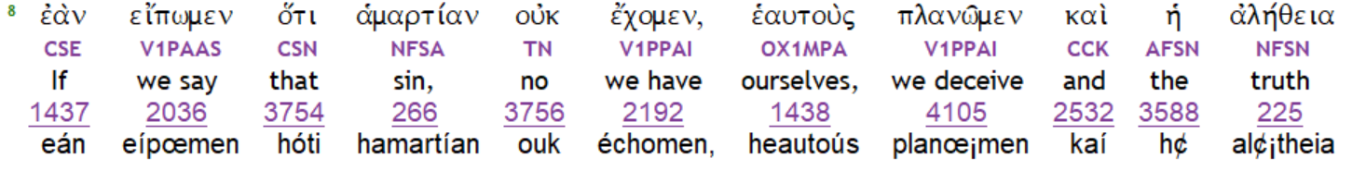

**Word – Strong’s 3056** – A word which, uttered by the living voice, embodies a conception or idea (plan) ; Also, the essential Word of God, I. e., the personal wisdom and power in union with God, John 1:1,14

We are hypocrites (saying we are something we aren’t) if we say that we are Christians and have totally surrendered to Him, but we deliberately keep on sinning and not seeking forgiveness**, neither the truth or His word is in us.**

So, if we look at the Greek definitions of **truth and word** above, when we say we don’t have sin in us, the notions of God and the purpose of Yahushua is not in us and God’s plan and purpose and power is not in us!

This means that Yahushua does not know us! He does not have a relationship with us. We may be religious and go to church, say we believe in God, are a good person, etc.… but if we haven’t completely submitted our lives to Yahuah and obeying everything that Yahushua asks of us, then they are not in us.

**What good is religion then? They are part of the world living in the flesh, not in the spirit of God.**

**John 14:22-**24 Judas (not Iscariot) said to him, **"Lord, how is it that you will manifest yourself to us, and not to the world?"** 23 Jesus answered him**, "If anyone loves me, he will keep my word, and my Father will love him, and we will come to him and make our home with him.** 24 Whoever does not love me does not keep my words. And the word that you hear is not mine but the Father's who sent me.”

**John 8:15-18,24-**27 “You judge according to the flesh; I judge no one. 16 Yet even if I do judge**, my judgment is true (truthful – the truth**), for it is not I alone who judge, but I and the Father who sent me. 17 In your Law it is written that **the testimony of two men is true. *18 I am the one who bears witness about myself, and the Father who sent me bears witness about me."*…24 I told you that you would die in your sins, for unless you believe that I am he you will die in your sins."** 25 So they said to him, "Who are you?" Jesus said to them, "Just what I have been telling you from the beginning. 26 I have much to say about you and much to judge, **but he who sent me is true, and I declare to the world what I have heard from him." 27 They did not understand that he had been speaking to them about the Father.”**

**John 18:35-37** “Pilate answered, "Am I a Jew? Your own nation and the chief priests have delivered you over to me. What have you done?" 36 Jesus answered**, "My kingdom is not of this world.** If my kingdom were of this world, my servants would have been fighting, that I might not be delivered over to the Jews. But my kingdom is not from the world." 37 Then Pilate said to him, "So you are a king?" Jesus answered, "You say that I am a king. For this purpose I was born and for this purpose I have come into the world**— *to bear witness* to the truth. Everyone who is of the truth listens to my voice." 38 Pilate said to him, "What is truth?"**

**Yahushua is the Truth! He does and says everything that the Father tells Him. God does not lie and He always stands by His promises and Yahushua is the exact representation of the Father. (Hebrews 1:3)**

**“One or two witnesses” This method of being God’s oracle of truth has been used throughout the Bible. He and the Father bear witness to the truth.**

**Deut. 19:15 - Moses relied on two witnesses to provide evidence of crimes.**

**2 Corinthians 13:1 - Paul – every charge must be established by the evidence of two or three witnesses.**

**Matthew 18:16 (known as the Matthew 18 Principle) Jesus on reconciliation in the church – take one or two witnesses to confirm the truth and charges.**

**1 John 5:6-10 - Testimony Concerning the Son of God. First, “This is he who came by water and blood—Jesus Christ; not by the water only but by the water and the blood. And the Spirit is the one who testifies, because the Spirit is the truth. 10 Whoever believes in the Son of God has the testimony in himself. 7 For there are three that testify: 8 the Spirit and the water and the blood; and these three agree. 9 If we receive the testimony of men, the testimony of God is greater, for this is the testimony of God that he has borne concerning his Son.”**

**Second, John speaks of Jesus as coming by “blood.” This is a reference of course to Jesus’ death on the cross. At the cross where Jesus Christ of Nazareth shed His blood forgiveness of sins was granted to all who believe.**

**Third, John speaks of “the Spirit who testifies” and is in “agreement” with the water and the blood which also testify to Jesus. Everything Jesus did while on the earth was by the power of the Holy Spirit who testified that Jesus was the Son of God (cf. Mark 1:12; Luke 1:35; Acts 10:38). In fact, Jesus was so adamant about this that He proclaimed that anyone who spoke against the Spirit was guilty of the eternal sin of blasphemy against the Holy Spirit (Matt. 12:31-32).**

**This same spirit of God that is the truth and witness of God through Jesus Christ, can be in us.** In the last days before Jesus returns, scripture says God’s word/truth/power will be manifested through us in ways even greater than Jesus had. (John 14:12) This is so we will draw the bride into a relationship with God and also be the evidence of God’s word/testimony and power.

I want to be part of this group that God finds faithful and trustworthy to use in any way He wants. I don’t want any selfishness, disobedience, self-will to get in the way. As Paul pleaded with the church of Corinth , I plead or beg you to join me – to be the righteousness of God in these last days. **(2 Corinthians 5:20)**

**In closing – “Jesus prayer to encourage us!” John 17:13-22 – “I have given them your word, and the world has hated them because they are not of the world, just as I am not of the world. 15 I do not ask that you take them out of the world, but that you keep them from the evil one. 16 They are not of the world, just as I am not of the world. 17 Sanctify them in the truth; your word is truth. 18 As you sent me into the world, so I have sent them into the world. 19 And for their sake I consecrate myself, that they also may be sanctified in truth.**

**20 "I do not ask for these only, but also for those who will believe in me through their word, 21 that they may all be one, just as you, Father, are in me, and I in you, that they also may be in us, so that the world may believe that you have sent me. 22 The glory that you have given me I have given to them, that they may be one even as we are one.**

**Will you remain surrendered to His Will and Way and allow your life to be a testimony of His truth?**

**Will you pick up your cross today and every day and follow Him?**