07/06/24 – The Minor Prophet Amos Part II
Mishpat (Justice) and Tsedaqah (right relationship)
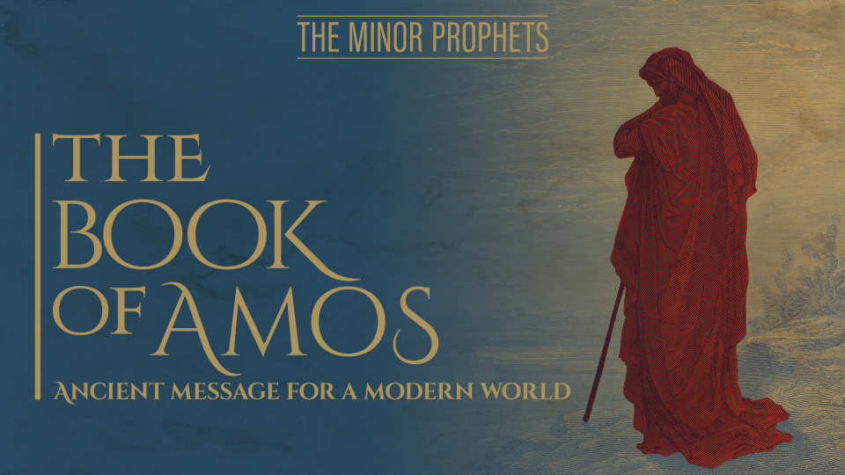

We are on days 9-13 of our companion study on YouVersion entitled “Amos: Seek the Lord and Live.” It walks us through chapters 3 and 4 of Amos.

In these chapters we see God’s accusations and judgement first against the enemies of Israel over the years (His Mishpat – (one by one- over the first chapter and first 4 verses of chapter 2). The Israelites may have initially enjoyed that and became complacent and secure and comfortable in their halfhearted or no hearted worship of The God of Creation. But that tune will change when the judgment on them comes in much greater intensity and detail from the 2nd chapter through the 4th chapter.

The judgements of each of the Cities and Israel and Judah start with: [For three transgressions enter City name, and for four] These expressions of three and four, mean repetition, abundance, and anything that goes toward excess. Very, very exceedingly; and it was used among the ancient Greek and Latin poets.
(From Adam Clarke's Commentary, Electronic Database. Copyright © 1996, 2003, 2005, 2006 by Biblesoft, Inc. All rights reserved.)

Further, there is a similar expression we use today regarding being “fed up”, which then causes someone to act: It is called “the straw that broke the camel’s back”. This is God’s attitude toward the enemies of Israel and the Israelites, who may feel safe and secure and even cheer God for coming against their enemies. However, we will see the result of their complacency and sin. They will not escape punishment either.

Let’s first look at a few of the judgements carried out on Israel’s enemies:

Amos 1:3, 4 Thus says the LORD, “For three transgressions of Damascus and for four
I will not revoke its punishment! Because they threshed Gilead with implements of sharp iron.
“So I will send fire upon the house of Hazael and it will consume the citadels of Ben-hadad. The fire threatened here is the war carried on against the Syrians by Jeroboam II., in which he took Damascus and Hamath, and reconquered all the ancient possessions of Israel. See 2 Kings 14:25-26,28.

Verses 6-8 Thus says the LORD, “For three transgressions of Gaza and for four
I will not revoke its punishment, [They carried away captive and God sent a fire on the wall of Gaza, which shall devour the palaces thereof: Gaza is well known to have been one of the five lordships of the Philistines; it lay on the coast of the Mediterranean Sea, near to Egypt, Erkon, Ashdod, and Askelon. The captivity mentioned here may refer to inroads and incursions made by the Philistines in times of peace. See 2 Chron 21:16. The margin reads, an entire captivity. They took it all away; none of them afterward returned.

Verses 9, 10 “For three transgressions of Tyre and for four [I will send a fire on the wall of Tyrus] The destructive fire or siege by Nebuchadnezzar, which lasted thirteen years, and ended in the destruction of this ancient city; It was finally ruined by Alexander, and is now only a place for a few poor fishermen to spread their nets upon.

Verse 11 [For three transgressions of Edom, and four] That the Edomites) were always implacable enemies of the Jews, is well known; but most probably that which the prophet has in view was the part they took in distressing the Jews when Jerusalem was besieged, and finally taken, by the Chaldeans. See Obad 11-14; Ezek 25:12; 35:5; Ps 137:7.

Then verse 12 – The Ammonites, Verses 13,14 - Rabbah - This was done by Nebuchadnezzar. See Jer 27:3,6.

Then chapter 2 verses 1, 2 [For three transgressions of Moab, and for four] The land of the Moabites lay to the east of the Dead Sea. For the origin of this people, see Gen 19:37. [He burned the bones of the king of Edom into lime] Possibly referring to some brutality, such as opening the grave of one of the Idumean kings, and calcining his bones. It is supposed by some to refer to the fact mentioned 2 Kings 3:26

But now we see God turn his wrath upon His Family with the evil done by Judah and Israel in verses 4 -8. He reminds them of all the things He had done for them, yet they turned their backs on Him.

The Book of Amos, Chapters 3 & 4 adapted from A Christian Growth Message by
Simon Manchester of All Saints Church in Woollahra Sydney,
On why God speaks this way… “It’s not because he’s a loose cannon but because he watches the world, He registers what’s taking place, He feels, He decides that He will settle things and he also watches the church, and He is dissatisfied with carelessness in the church. Where there is lifeless orthodoxy – He will change it. And He will, if necessary, sift the church, He’ll refine it, He’ll purge it, He’ll weed it. And He’ll do this because He is committed to having a real people who walk with him and rejoice with him and delight in him and grow like him.”
Ch 3 Verses 1 & 2 – “Listen Israel, listen family (there is a loaded word ‘family’ in verse1) because He would think the family of His people as being Israel and Judah even though they are separated – He sees them as one family,
This is the only time in the Old Testament that God calls Israel His family. He loves the people enough to visit them because they are going off track and His commitment means that even if it’s going to be a difficult visit, He’s not going to avoid it, He’s going to make the visit, and unfortunately, it’s going to be a costly visit.

Riddles To Get Our Attention - But here is Amos with seven riddles in chapter 3 verses 3-6 designed to get the attention of the people of Israel and the seven riddles are riddles of logic. They are not all that complicated.
The riddle is asking the question: “Do you think “B” is happening without “A” causing it?
So look at verses 3-6:
Do you think two people are walking together without a decision behind it?
Do you think a lion roars for nothing?
Does a bird get trapped if there is no trap?
Does the trumpet sound for no reason?
Does disaster hide a city and God is not behind it?
And then says Amos (verse 7) “God has revealed his plan” (verse 8) “He has roared” – there is a reason why I am here.
I think this is very clever because Amos is saying to the people of Israel, do you realize why I’ve come up from the South, do you think I’ve come for no reason, do you think I’ve just turned up to hang out? – No, no, no. God has spoken, and I am the messenger, and there is logical reason why I am here.
Well, not only is there logic in the riddles but there is also something unsettling about them except for verse 3. We see the hurt to the heart of God and the betrayal He must have felt.
Does He feel betrayed today? With the way we seek Him?, are we seen as offering God a living sacrifice of praise?
This one riddle that is full of God’s emotion where the He asks, “Do two walk together unless they have agreed to do so?” And behind this is the reminder that God amazingly agreed to walk with these people, and he did walk with them. And they agreed to walk with him, and God said to them “Walk before me and be blameless, walk in the way that I command you”. “Didn’t we agree to walk together?” says the Lord.

Are We Walking with The Lord? And we could ask this question each morning, couldn’t we? There are many here who at some stage in the past decided that they would walk with the Lord but in a strange way and for some strange reason, are not walking with the Lord.
“A section that follows from verse 9 that he’s going to call on two witnesses who will come and watch his behavior and they will testify to his decision to bring in an enemy to sift his people. And of course, 2 witnesses would always establish the truth of something and make sure that nobody could doubt that what was taking place was talking place and as I say, the truth that God wanted witnessed was that He was going to bring Assyria in to sift his people. But look at the 2nd witnesses He chose- it’s unbelievable – He chose one called “Ashdod”, the Philistine city – think Goliath – think brutal enemy and he’s going to have “Egypt” come in as another witness – that’s the prison they left a long time before – think captivity – think Pharaoh – think godlessness. These are the two cities that God says, ‘I want you two to come and watch the sifting of my people’.”
And still we see (verses 10-12) that there is going to be a remnant of God’s people that are spared and are righteous.
(Verse 15) “The mansions that make you feel so safe and sturdy and at east, I am going to remove those as well”. So, the religious refuge and the non-religious refuge are going to be taken away, and it was taken away. What Amos said in 760-750BC all took place in 722BC when the Assyrians came in, and they removed the places of refuge and what God said he would do, he did.
In Ch 4 Amos makes a point about the women in this particular situation being well off, well to do and they are absorbed in themselves. They graze peacefully for themselves, they don’t have a care in the world, they are disinterested in everybody, but themselves and they have no time for God.

God Looks at Our Heart 1 Samuel 16:7 “But the LORD said to Samuel, “Do not look at his appearance or at the height of his stature, because I have rejected him; for God sees not as man sees, for man looks at the outward appearance, but the LORD looks at the heart.”

I think this is such a sobering thing that we deal with a God who is so loving – it’s heart to heart. It’s like being married to the most serious bridegroom in the world. He’s out for our progress and He will not settle for mediocrity or decline.
And it is a sobering thing, isn’t it, imagine if somehow a light was able to be brought down from the roof and it lit up the people in the pews and in the pulpit whose heart today was inclined seriously to God. And I just wonder how many people that light would settle on? It would shock us, wouldn’t it?
To suddenly realize that in the pulpit or the pew, we’ve been seen as people who are here are singing, and saying and preaching and listening and there’s no light because God knows that our heart is somewhere else. That’s the God that we deal with. He knows us, and He doesn’t play our games, and He can see through us just as we can see through very, very bad acting. And what He simply looks for is a broken heart, a contrite heart, a humble heart, and a genuine heart – that’s who He loves and lives with.
But we see the opposite of this type of heart with the Israelites as we read in verses 4 and 5. We see God’s hurt and betrayal and His anger with His family. So much so, He even resorts to sarcasm:
“Enter Bethel and transgress, In Gilgal multiply transgression! Bring your sacrifices every morning, Your tithes every three days. “Offer a thank offering also from that which is leavened, and proclaim freewill offerings, make them known. For so you love to do, you sons of Israel,” Declares the Lord GOD.” This is a reference Ch 3:14 and 1 Kings 12 in their grabbing and worshipping the horns of the Altar where the calves stood. Evil King Jeroboam I created two golden calves and placed them on the Altar in Bethel to provide an easy alternate worship for the 10 tribes of Israel and prevent them from proper worship in Jerusalem. He was afraid of losing His kingdom.
“For on the day that I punish Israel’s transgressions, I will also punish the altars of Bethel; The horns of the altar will be cut off and they will fall to the ground.
Well, Israel, of course, had no inward reality, and therefore God is coming to judge. And it’s not as though he has not been trying to bring them back because in verses 6-11, he has been using a whole series of ‘wake-up’ calls to get them to return to him.
***********************
We read in verse 6 that he sent a famine (that should have reminded the believers, shouldn’t it?)
Verse 7 – He held back the rain – he caused it to fall in one place but not in another.
Verse 9 – He struck down their business.
Verse 10 – He sent plagues – they should have been saying to themselves at that point – why would we be getting plagues, don’t plagues go to Egypt?
Verse 11 – He scorched their towns – and again they might have said to themselves, I thought this has what happened to Sodom and Gomorrah, but now it’s happening to us.
And now since Israel is not coming back to God, God is coming to Israel, and He’s coming to visit them, and he’s coming to visit them seriously. And verse 12 is maybe the most famous verse in the Book of Amos which says, “Prepare to meet your God”.
These Amos chapters are painting a wonderful God who won’t settle for spiritual deadness in his people. I am so thankful for this.

Even so, He still offers them mercy and a hope if they respond after hearing the judgement. This shows His unfailing love for His people and that we serve a God of second and third chances, but we should not try His patience (Hebrews 10 – do not insult the spirit of His favor.) His desire is that we all will come into a deep intimate relationship with Him and cherish and protect that relationship above all others.

- How does God see us today? As someone walking with and In Him?
- Are we a man or woman who He would call as a person after His own heart (like David)?
- Are we listening to Him and His conviction? Or does He have to wake us up with extreme measures like He did with the Israelites?
- Are we heeding Jesus’ and Amos’ warning about the deceitfulness of worldly wealth accumulation? Scripture tells us we cannot worship God and money.

