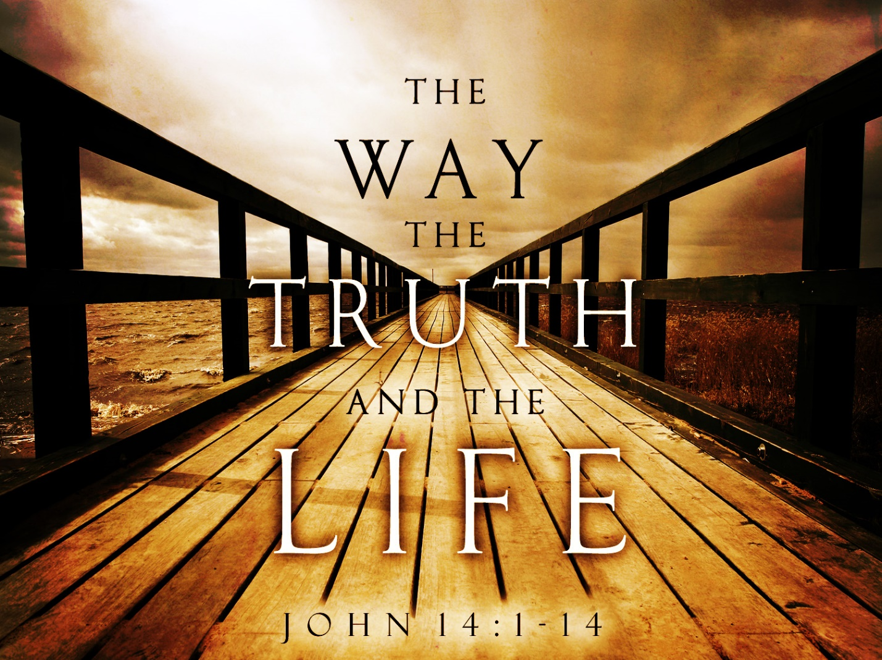

Opening thoughts: Quality of prayer life = ability to walk in the spirit.

Here are some questions to reflect on the condition of your spiritual life:

* Are you in bondage to the ways of the world? Maybe the snare of addiction?
* Are you stuck in a spirit of depression or anxiety?
* How is your prayer life? Do you seek Him with all your heart every day?
* Are you in His word daily?
* Is Yahuah and His kingdom your priority or does something else take a priority?
* Is your life a testimony of the love of Yahushua? Loving without expectations.
  + What would your brother or sister or wife or husband say?
* Do you have any good fruit?
* Are you sharing His love to others? Or hiding His light?
* Do people see Yahushua in you? Or are you a reflection of this world?

If Yahushua were here in our presence (face to face), would he say he knows you and sees you as a good and faithful servant of His Father?

We should have the heart motive to love Yahuah with all of our heart, soul, mind, and strength and then we are able to love our neighbor as ourselves.

**WE ARE CALLED TO LIVE LIKE YAHUSHUA**! “He is the way! - He is the pattern son – our example of how to be the righteousness of Yahuah.

### Part I - I Am the Way, and the Truth, and the Life

**John 14 “Let not your hearts be troubled. Believe in God;[**[**a**](https://www.biblegateway.com/passage/?search=John+14&version=ESV#fen-ESV-26658a)**] believe also in me.** **2**In my Father's house are many rooms. If it were not so, would I have told you that I go to prepare a place for you?[[b](https://www.biblegateway.com/passage/?search=John+14&version=ESV#fen-ESV-26659b)] **3**And if I go and prepare a place for you, I will come again and will take you to myself, that where I am you may be also. **4**And you know the way to where I am going.”[[c](https://www.biblegateway.com/passage/?search=John+14&version=ESV#fen-ESV-26661c)] **5**Thomas said to him, “Lord, we do not know where you are going. How can we know the way**?” 6Jesus said to him, “I am the way, and the truth, and the life. No one comes to the Father except through me. 7If you had known me, you would have known my Father also.[**[**d**](https://www.biblegateway.com/passage/?search=John+14&version=ESV#fen-ESV-26664d)**] From now on you do know him and have seen him.”**

**8**Philip said to him, “Lord, show us the Father, and it is enough for us.” **9**Jesus said to him, “Have I been with you so long, and you still do not know me, Philip? Whoever has seen me has seen the Father. How can you say, ‘Show us the Father’**? 10Do you not believe that I am in the Father and the Father is in me? The words that I say to you I do not speak on my own authority, but the Father who dwells in me does his works. 11Believe me that I am in the Father and the Father is in me, or else believe on account of the works themselves.**

**12**“Truly, truly, I say to you, whoever believes in me will also do the works that I do; and greater works than these will he do, because I am going to the Father. **13**Whatever you ask in my name, this I will do, that the Father may be glorified in the Son. **14**If you ask me[[e](https://www.biblegateway.com/passage/?search=John+14&version=ESV#fen-ESV-26671e)] anything in my name, I will do it. (End-times message)

### Jesus Promises the Holy “Set-Apart” Spirit

**15“If you love me, you will keep my commandments. 16And I will ask the Father, and he will give you another Helper,[**[**f**](https://www.biblegateway.com/passage/?search=John+14&version=ESV#fen-ESV-26673f)**] to be with you forever, 17even the Spirit of truth, whom the world cannot receive, because it neither sees him nor knows him. You know him, for he dwells with you and will be[**[**g**](https://www.biblegateway.com/passage/?search=John+14&version=ESV#fen-ESV-26674g)**] in you.**

**18**“**I will not leave you as orphans**; I will come to you. **19**Yet a little while and the world will see me no more, but you will see me. Because I live, you also will live. **20**In that day you will know that I am in my Father, and you in me, and I in you. **21Whoever has my commandments and keeps them, he it is who loves me. And he who loves me will be loved by my Father, and I will love him and manifest myself to him.”** **22**Judas (not Iscariot) said to him, “Lord, how is it that you will manifest yourself to us, and not to the world?” **23**Jesus answered him, **“If anyone loves me, he will keep my word, and my Father will love him, and we will come to him and make our home with him.** **24**Whoever does not love me does not keep my words. And the word that you hear is not mine but the Father's who sent me.

**25“These things I have spoken to you while I am still with you. 26But the Helper, the Holy Spirit, whom the Father will send in my name, he will teach you all things and bring to your remembrance all that I have said to you. 27Peace I leave with you; my peace I give to you. Not as the world gives do I give to you. Let not your hearts be troubled, neither let them be afraid.** **28**You heard me say to you, ‘I am going away, and I will come to you.’ If you loved me, you would have rejoiced, because I am going to the Father, for the Father is greater than I.

**What is meant by Yahushua when he says he “Is the Way”?**

In the first century when Jesus was ministering, people would call his disciples followers of “The Way”.

This meant that the life Yahushua lived was to be our living example. He showed us how to live in the Father’s will. Through accepting him, obeying him and remaining in him, we can be reconciled with the Father. We can enter into and maintain a relationship with Yahuah just like Yahushua had and Adam and Eve had before the fall. Yahushua is known as the 2nd Adam and **he makes a way** (Yahuah’s logos – plan) **for us to be restored to Yahuah** similar to the relationship the 1st Adam had.

### God’s Final Word: His Son (NIV) – The exact representation of Yahuah!

**Hebrews 1:1 “**In the past God spoke to our ancestors through the prophets at many times and in various ways, **2**but in these last days he has spoken to us by his Son, whom he appointed heir of all things, and through whom also he made the universe**. 3The Son is the radiance of God’s glory and the exact representation of his being, sustaining all things by his powerful word.”**

### Walking in the Light – 1 John 1:5-10

**5**This is the message we have heard from him and proclaim to you, that God is light, and in him is no darkness at all. **6**If we say we have fellowship with him while we walk in darkness, we lie and do not practice the truth. **7But if we walk in the light, as he is in the light, we have fellowship with one another, and the blood of Jesus his Son cleanses us from all sin.** **8If we say we have no sin, we deceive ourselves, and the truth is not in us. 9**If we confess our sins, he is faithful and just to forgive us our sins and to cleanse us from all unrighteousness. **10**If we say we have not sinned, we make him a liar, and his word is not in us.

**1 John 3** “**6 whoever says he abides in him ought to walk in the same way in which he walked.”**

**1 Peter 2** “21 For to this you have been called, because **Christ also suffered for you, leaving you an example, so that you might follow in his steps.”**

**How do we follow in his steps?**

**Jesus says that if we obey him like he obeys the Father he will live in us and the Spirit of Yahuah will be our helper**. We cannot “walk in the Spirit of Yahuah” on our own power or in our own way. No matter how hard we try to change on our own unless we are totally surrendered to him, we will not be able to do it!

**Once again…John 14 25“These things I have spoken to you while I am still with you. 26But the Helper, the Holy Spirit, whom the Father will send in my name, he will teach you all things and bring to your remembrance all that I have said to you.**

It all comes down to the motives of our heart. Are we **totally surrendered** to His will **and His way** or not? Do you trust Yahuah with everything? You can’t be on the fence and partly rely on your own experiences, plans, emotions, etc. and partly on His will - We cannot live a lukewarm life! In fact, that is worse that being cold and rejecting Him. Why is this so? Hypocrisy and the mainstream Harlot Church!

**Rev 3:14-22** **- Message to Laodicea** "To the angel of the church in Laodicea write:

The Amen, the faithful and true Witness, the Beginning of the creation of God, says this: **15 'I know your deeds, that you are neither cold nor hot; I wish that you were cold or hot. 16 So because you are lukewarm, and neither hot nor cold, I will spit you out of My mouth.** 17 Because you say, "I am rich, and have become wealthy, and have need of nothing," and you do not know that you are wretched and miserable and poor and blind and naked,

**18 I advise you to buy from Me gold refined by fire so that you may become rich, and white garments so that you may clothe yourself, and that the shame of your nakedness will not be revealed; and eye salve to anoint your eyes so that you may see**. (stay awake)

**21 He who overcomes, I will grant to him to sit down with Me on My throne, as I also overcame and sat down with My Father on His throne. 22 He who has an ear, let him hear what the Spirit says to the churches.'"** NASU

We can be overcomers and like Jesus, we can be the righteousness of God and share in His divine glory! **He promises will can do it and His divine power will be given to us “for all things pertaining to life and godliness”. (2 Peter 1:3)**

**We must surrender our desires (Die to self-will) and submit to the will of Yahuah and be a follower of “The Way”.**

## **Definition of surrender (Entry 1 of 2)**

[*transitive verb*](https://www.merriam-webster.com/dictionary/transitive)

**1a:**to yield to the power, control, or possession of another upon compulsion or demand *surrendered* the fort

**b: to give up completely or agree to forgo especially in favor of another**

**2a:**to give (oneself) up into the power of another **especially as a prisoner**

**b:**to give (oneself) over to something (such as an influence)

[*intransitive verb*](https://www.merriam-webster.com/dictionary/intransitive)**: to give oneself up into the power of another :**[**YIELD**](https://www.merriam-webster.com/dictionary/yield)

**Closing: We can only be overcomers if we humble ourselves and become prisoners to Yahushua and be followers of God’s will and Yahushua’s way. We must totally surrender our lives, plans, ways of life, everything to Him. Join me today in doing this - we will have everlasting joy and a deep faith that is not shaken during times of trouble (like the momentary and light shaking we are going through now). It is going to get more and more difficult in the next few years when Yahushua’s return draws near.**