07/20/24 – The Minor Prophet Amos Part IV
Mishpat (Justice) and Tsedaqah (right relationship)

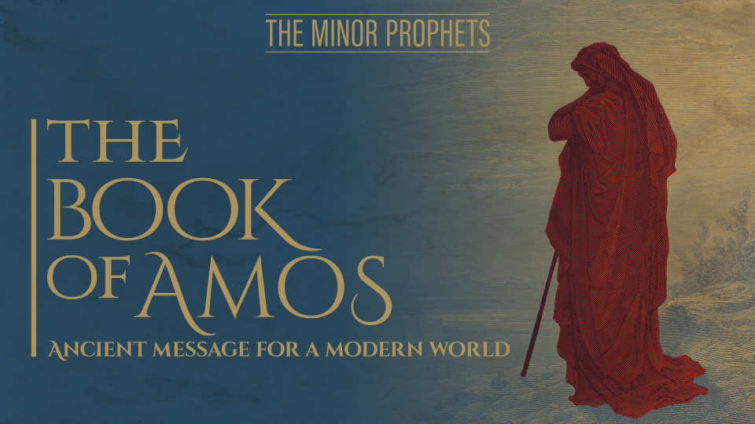

So far, we’ve looked at:
- The first two chapters: where God the Lion roars against Israel and their enemies.
- The second two chapters: we saw that God declares that He will visit His people.
- The fifth and sixth chapters: God makes an appeal to His people to return to Him so that he will not have to visit them for judgement.

Now we turn to chapters 7 and 8 we see the compassion of God for His people amidst His readiness to exact justice.

There are five visions over the next couple of chapters (7:1-3, 4-6, 7-9; 8:1-3; 9:1-4). Between the third and fourth visions there is a narrative of a conflict between Amos and Amaziah, priest of Bethel (7:10-17); a series of oracles about death and famine (8:4-14) separate the fourth and fifth visions. The entire sequence contributes to the theme of death and the end of Israel.

(first vision) Thus, the Lord GOD showed me, and behold, He was forming a locust-swarm when the spring crop began to sprout. And behold, the spring crop was after the king’s mowing. And it came about, when it had finished eating the vegetation of the land, that I said, “Lord GOD, please pardon! How can Jacob stand, for he is small?”
The LORD changed His mind about this. “It shall not be,” said the LORD.

(Second vision) Thus the Lord GOD showed me, and behold, the Lord GOD was calling to contend with them by fire, and it consumed the great deep and began to consume the farmland. Then I said, “Lord GOD, please stop! How can Jacob stand, for he is small?”
The LORD changed His mind about this. “This too shall not be,” said the Lord GOD.

***Did God really change His mind? 1 Samuel 15:29 “The Glory of Israel will not lie or change His mind; for He is not a man that He should change His mind.”

In our day 22 of 31 YouVersion study on Amos, the author says “God relented or changed His mind these two times because He always intended to. He was wanting to see if Amos would plead and beg Him to have mercy on Israel.

(Third vision) Thus He showed me, and behold, the Lord was standing by a vertical wall with a plumb line in His hand. The LORD said to me, “What do you see, Amos?” And I said, “A plumb line.” Then the Lord said, “Behold I am about to put a plumb line.
In the midst of My people Israel. I will spare them no longer. “The high places of Isaac will be desolated, and the sanctuaries of Israel laid waste. Then I will rise up against the house of Jeroboam with the sword.”

In these visions, Amos uses three symbols in explanation of his prophecies: (1) A vision of grasshoppers or young locusts, which devour the grass, but are removed at Amos' pleading; (2) Fire drying up even the deep, and withering part of the land, but removed at Amos' pleading; but finally, (3) A plumb-line to mark the buildings for destruction.

The third symbol isn’t as general as the first two, it directly addressing Israel. God's long-suffering is worn out by Israel's perversity. Amos ceases to intercede (compare Ge 18:33). The plumb line was used not only in building, but in destroying houses (2Ki 21:13; Isa 28:17; 34:11; La 2:8). It denotes that God's judgments are measured out by the most exact rules of justice. – JFB adapted.
We can see here God’s compassion is a desire to hold back justice for as long as he can. This is in hope that His people will repent and once again only worship Him as the true God. And the second sign of God’s compassion is that he is speaking, warning, communicating and appealing as long as he can.
The person who keeps silent when they are watching somebody move toward danger doesn’t seem to care about the person running toward danger. The person who speaks up when someone is walking toward danger appears to be the person who speaks up, and God speaks up as he watches his people move towards this danger.
And what we have in the second half of Amos chapter 7 is a little struggle that takes place between speaking and not speaking because a man called Amaziah that is a priest, a priest who was obviously just a professional priest and apparently not a very godly priest. We might say that Amaziah was like an ungodly Archbishop who has an Office and Power but doesn’t care about the Word of God.
Amaziah stepped forward mainly to say to Amos – “Keep Quiet and Go Home”. And he writes to the king, Amaziah (7:10) a series of lies. adapted from A Christian Growth Message by Simon Manchester of All Saints Church in Woollahra Sydney,
Amaziah says:
- King, you may be interested to know (7:10) that Amos is raising a conspiracy against you – well, that’s fake news!
- You may be interested to know that the land is being threatened by Amos – well, that’s fake news also; the truth is the land is going to be threatened if you don’t listen to Amos.
- You may be interested to know that Amos says you are going to be killed with the sword – another fake news report. Amos has merely said that God would bring the sword on the nation.
Then, we see a little clash taking place here of the false and the true prophet. The false prophet is twisting the words and ordering Amos to go home and earn his money back in Judah. And it must have been somewhat scary for Amos to be told ‘go home’ by somebody who has high Office.
But Amos knows who is behind him, and I love what he says in chapter 7 verses 14-15 – how’s this for a way of establishing your credentials?
Then Amos replied to Amaziah, “I am not a prophet, nor am I the son of a prophet; for I am a herdsman and a grower of sycamore figs. But the LORD took me from following the flock and the LORD said to me, ‘Go prophesy to My people Israel.’ Now hear the word of the LORD: you are saying, ‘You shall not prophesy against Israel, nor shall you speak against the house of Isaac.’ Therefore, thus says the LORD, ‘Your wife will become a harlot in the city, your sons and your daughters will fall by the sword, your land will be parceled up by a measuring line and you yourself will die upon unclean soil. Moreover, Israel will certainly go from its land into exile.’”
Amos is a strong man in the face of pressure. He is set free from the desire to be popular – he speaks the truth and doesn’t water down God’s message to be PC.
And the second thing is that he has an answer for the person who says, ‘who says so?’ Because Amos’ answer is ‘God says so’.
What does God’s justice look like:
Now the second point –you’ll see it in chapter 8 verse 1 where there is a fourth vision, which is a basket of ripe fruit.
The reason that Amos sees a basket of ripe fruit is that God is saying the time is ripe for God’s people to be disciplined.
Here are several other ways that God disciplines his people:
- Verse 7, God takes an oath, he won’t forget anything, and everything has been noticed.
- Verse 8, Israel, the land, is going to be flooded. It’s not going to be flooded with water; it’s going to be flooded with the Assyrians.
- Verse 9, there’s going to be darkness, probably not literal darkness but some kind of great spiritual darkness even in the middle of the day.
- Verse 10, there will be great mourning, weeping, sadness like losing an only son and most serious of all.
- Verses 11 & 12, there is going to be a famine but it’s not a famine of bread, it’s going to be a famine of the Word of God. God is going to be silent and stop speaking.
How do you feel when a family member or a friend starts giving you the silent treatment? It when somebody stops talking to you that you used to talk with all the time. It’s unsettling, it’s distressing, it’s perplexing. And when God, the God of the Universe, stops speaking, that’s the ultimate breakdown. The people who have despised the truth now discover that the truth walks away.
In verse 13 lovely women and strong men will also faint from thirst. Then, in verse 14, the idols fall.
Also, I don’t think we can miss as we read these verses the reminder of what these words describe –
- Overwhelming judgment
- Darkness
- The loss of an only son
- Silence
That’s Calvary – that’s what took place at the Cross.
You can’t read the end of the Gospels and not see Jesus going through an overwhelming judgment. What he called a Baptism of Fire and the darkness at midday and the death of an only son and the silence because he calls out “Why have you abandoned me?” and gets no reply.
That’s the judgment of God falling on Jesus. Why is the judgment falling on Jesus back at Calvary? Because God loves us so much He would rather die than see you get judgment. And He has made a provision for us through Jesus. That’s the God of the Bible, the very great, compassionate, and just God of the Bible.
With the help of the Holy Spirit, please join me in overcoming some of the sin that the Israelites committed.
I want to be a more thankful person because God has saved me from darkness and from grief and from silence.
- I want to be a more faithful person.
- I don’t want to test his patience.
- I don’t want to play Christianity.
- I also want to be a godly person.
- I want to be more like Amos as he was so concerned for the lost.
- I want to be patient with sinners (because God has been very patient with me).
- I want to be truthful – saying what needs to be said.

